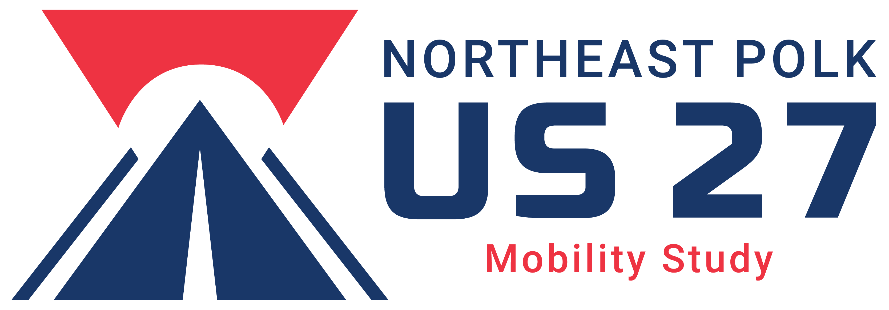 MEETING SUMMARY
Copies to: | Sarah Catala, FDOT  Consultant Team  PAG Meeting Invitees |  | Date: |  |  | December 19, 2018  FINAL
Project: | NE Polk US 27 Mobility Study  Polk County |  | Project No.(s): |  | FPID No. 440320-1-22-01  AEP: 1040058000
Meeting Place: | Winter Haven Regional Airport  2073 US Highway 92 West  Winter Haven, FL 33881 |  | Meeting Date: |  |  | November 13, 2018
 |  |  | Meeting Time: |  |  | 10:00 a.m.
Participants: | Kathy Bangley, Lake Wales  Ronnie Blackshear, Polk TPO  Sean Byers, Winter Haven  Katherine Chinault, FDOT D1  Heather Garcia, FDOT D5 (by phone)  David Holley, Saddle Creek  Cyndi Jantomaso, Haines City EDC  Bruce Lyon, Winter Haven EDC  Sean Malott, Central Florida Development Council  Robert Richard, Longleaf Business Park (by phone)  Rod Wetzel, Citrus Connect  John Wrublik, USFWS (by phone) |  |  | Sarah Catala, FDOT, D1 Project Manager  Rick Langlass, RS&H, Consultant Project Manager  Lisa Dykstra, RS&H (by phone)  William Roll, Kimley-Horn  David Nelson, Renaissance  Katrina Corcoran, Renaissance
Purpose: | Project Advisory Group Meeting #1

Sarah Catala opened the meeting with a welcome and introduction. She provided an overview of the study, outlining that the study area is a 32-mile stretch of US 27 from SR 60 on the south to US 192 on the north and that the project will define a multimodal program of projects and strategies to improve the mobility, safety, and livability of the US 27 corridor and surrounding area. Sarah referenced the project vicinity map (which was handed out to attendees) and noted that the study area covers an area much larger than the US 27 corridor itself, in order to consider regional connections to the east and west in addition to those north and south along US 27.

David Nelson discussed the Project Advisory Group (PAG), noting that the group is comprised of members with specific knowledge of the US 27 corridor and/or surrounding study area (such as city and county staff, FDOT staff, M/TPO staff, RPCs and EDCs, business community, transportation providers, and environmental agencies; see end of summary for complete list of invitees). He stressed that the overarching purpose of the PAG is to facilitate collaboration between stakeholders to ensure that study outcomes consider input from all perspectives. Specific expectations of the PAG include:

- Attend meetings throughout the life of the study (6 to 7 meetings)
- Provide expertise, information, and input into the study
- Represent the interests of their larger agency, community, business, etc. and act as a link between such and the project team to share information
- Provide input into measurable objectives, evaluation criteria, and potential alternatives

The PAG members (both in person and by telephone link) introduced themselves, followed by FDOT representatives and the consultant team. A list of project contacts was handed out to attendees (and is included at the end of this summary).

Rick Langlass gave an overview of the project, detailing that the project will address safety, congestion, and mobility issues; accommodation of all transportation users; and define short- and long-term projects, priorities, and strategies. The general timeline for the project runs from June 2018 to February 2021, although there will be an effort to shorten the end date of the study if possible. Rick outlined the project process, which includes three parts:

- Phase I: Define the Problem – includes initial stakeholder outreach, data collection, and a synthesis of issues and opportunities
- Phase II: Define Guiding Principles – includes defining the guiding principles; defining the purpose and need; and defining the measures of success
- Phase III: Define and Select Alternatives – includes defining alternatives; comparing alternatives; selecting alternatives; and determining next phases

David Nelson discussed stakeholder engagement, noting that meetings with stakeholders are ongoing and, that to date, five Polk County Commissioners, six municipalities, five freight operators, and two economic councils have been interviewed. He noted that although each group assessed the corridor from a slightly different perspective, there was not only a general commonality of themes, but consistency with the stated goals from the Florida Transportation Plan. Highlights from interviews include:

- Polk County Commissioners
- Show incremental progress (and potential short-term projects) during the study
- Streamline planning activities where efficient and effective for timing purposes
- Keep Commissioners informed of study progress

- Municipalities
- Create alternative routes and improve connections
- Identify specific roadways for improvements
- Plan for multimodal improvements, especially intersection improvements and sidewalks

- Freight Operators
- Increase length of traffic signal “yellow phase”
- Create frontage roads along US 27 to reduce access points and conflicts
- Open to using toll roads if time savings outweigh costs

- Economic Councils
- Freight and logistics are natural economic development clusters for Polk County because of access to both Orlando and Tampa
- High interest and activity near I-4 interchanges
- High tech in the future with growth of Florida Polytechnic University

Rick Langlass described strategies that came from stakeholder interviews that will be considered. A list of strategies on US 27 were described, including:

- Adding capacity (lanes)
- Frontage roads
- Intersection improvements
- Multimodal improvements

Strategies to consider off US 27 include:

- Widening existing roadways
- New regional roadway connections
- Improving existing regional roadways
- New multimodal regional connectors
- Intersection improvements

Sarah Catala discussed some of the initiatives that FDOT is currently planning and/or implementing in the study area, including:

- US 27
- US 27 and I-4 interchange
- US 27 and SR 60 interchange – reconfiguring cloverleaf design
- US 27 adaptive signal control project (from Eagle Ridge Mall to Ronald Reagan). [Katherine Chinault, FDOT District One Traffic Operations provided an overview of the project, noting that it has been active since August 2018 and that signal timings will be adjusted based on data results and follow-up FDOT evaluation]
- Other Corridors
- I-4 and CR 557 interchange – in the FDOT 5-year Work Program with construction planned in fiscal year 2020
- CR 557 and US 17/92 – PD& E studies
- SR 544 – PD&E Study planned from Martin Luther King to US 17/92
- SR 542 widening
- CR 532 – looking at improvements with FDOT District 5
- I-4/Poinciana Parkway Connector – considering alternative routes

Rick Langlass discussed ongoing study efforts and next steps in Phase I, including data collection, continued stakeholder outreach and interviews, and issues/opportunities synthesis. He also outlined some of the public engagement efforts, including:

- Utilizing a variety of social media sources to reach most stakeholders
- Coordinating with municipalities for more traditional outreach efforts
- Using MetroQuest for short online surveys
- Utilizing the project web site http://swflroads.com/us27/mobilitystudy/

During the meeting, PAG members made comments or asked questions regarding the following topics:

Related to Emerging and Common Themes

- What does “providing connectivity” mean? [Sarah Catala responded that it means different things to different groups – for freight haulers, it’s about providing access between areas or developments to expedite deliveries; for municipalities, it’s about linking destinations and providing easy access to Orlando and Tampa areas]
- A question was asked about providing conduit for future technologies as part of roadway projects. It was noted that emerging technologies are required to be included as part of the Transportation Planning Organization’s new LRTP.
- Recommend that the team coordinate with Kim Long, Director of Polk Vision. They are working on a “smart communities” initiative, as well as other economic and community activities (involving social and health programs). [kim@polkvision.com, 863.940.2888, http://portal.polkvision.com ]
- It was suggested to talk with MPOs along the I-4 corridor, perhaps contact Eric Hill at MetroPlan Orlando.

Related to Development of Alternative Routes

- One way to take traffic off US 27 is to provide alternate routes in lieu of the Central Florida Parkway. The team should coordinate with Todd Dantzler, FCC Chair, who is leading an advisory group on this subject and share information between our two groups.
- Is there a way to replace the eastern leg of the proposed Central Polk Parkway extension to provide similar connectivity to what was originally planned and open up development opportunities?
- Please consider multimodal regional network systems such as Brightline and a SunRail extension.

Related to Development

- Winter Haven has identified three clusters for future industrial development.
- Is it possible to coordinate land-use planning in Polk County for all municipalities to agree on where to put types of new development? There is a need to coordinate long-term planning between municipalities to provide efficiencies in designation of future development areas. [Sarah Catala commented that better communication can help facilitate some of these plans]
- The Polk TPO is putting together a development tracker.
- Timing and certainty of new roadway projects is important as it influences development.

Related to Strategies On and Off US 27

- People are working hard to avoid US 27 and this puts more pressure on small municipalities that are receiving this increased traffic. Members commented that a lot of people who visit Legoland are using alternative routes such as CR 557 to avoid traffic and crashes on US 27 and get on I-4 west of US 27. Avoiding crashes also causes other problems. [Sarah Catala noted that CR 557 has come up multiple times in interviews]
- Recommend looking at ways to improve roadways that serve as alternative routes for accident avoidance and detours.
- Freight transporters use GPS and computer programs to avoid traffic problems, but their programmed alternative routes are not always good. [David Nelson commented that Lake Hamilton staff reported that trucks often get routed through their downtown or residential areas and that the roads are not designed for continued heavy traffic]
- A member noted there is cut-through traffic in Lake Wales near where people walk close to the interchange at US 27 and SR 60.

Related to Planned and Ongoing FDOT Projects in the Area

- There was a question regarding the SR 542 project. It was noted that a design project was underway on the east side.
- There was a question regarding the SR 544 project. It was noted that an advertisement for a PD&E Study would be out in the next 12 months. They also asked if it includes rebuilding the MLK intersection. [Sarah Catala noted that it is still to be determined and has not been precluded.] A member noted that there are challenges through the Park Villa area and the neighborhood has been disenfranchised.
- There was a question regarding if the intersection of US 27 and SR 544 would become an interchange.
- A member commented that there is a new federally designated opportunity zone in the area.

Related to Next Steps and Other Comments/Questions

- A Member requested that the PowerPoint presentation be posted on the NE Polk US 27 Mobility Study website.
- Ronnie Blackshear with the Polk TPO noted that the TPO can provide help with sharing the MetroQuest surveys through their contact list and advisory network.
- Are the Regional Planning Councils (RPCs) being involved in this Project Advisory Group? [Yes, representatives of the East Central Florida RPC, Central Florida RPC and Southwest Florida RPC have been invited to attend]
- Are flyovers being considered at major intersections? [Yes]
- Are there any workshops or public forums planned? We need to educate people about what’s going on. [Sarah Catala commented that FDOT is considering options]
- Can Polk Government Television (PGTV) be used as part of the stakeholder engagement process? [Ronnie Blackshear can help coordinate if this is something needed]
- The Polk TPO has a freight and Non-Motorized Travel Study that they can provide to the team. The information may be useful to this study.

David Nelson reminded members that the next PAG meeting is tentatively planned for March 2019 and that it would be more interactive, as the consultant team would be completing the Phase I tasks and have data for the PAG to react to. David asked if the Winter Haven Regional Airport was a convenient location to hold future meetings and received affirmative confirmation.

The meeting adjourned at approximately 11:30 a.m.

Respectfully submitted,

RENAISSANCE PLANNING
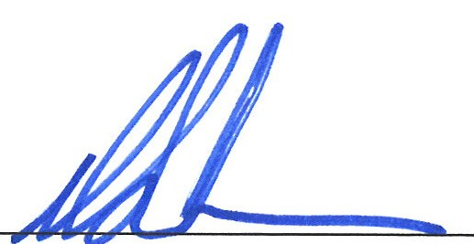
David Nelson, PLA, ASLA, LEED AP BD&C
Partner and Stakeholder Engagement Task Leader

Project Contacts

FDOT District One Project Manager
Sarah Catala, FDOT
District One Strategic Intermodal System (SIS) Coordinator
Growth Management Coordinator
10041 Daniels Parkway
Fort Myers, Florida 33913
239-225-1981
sarah.catala@dot.state.fl.us

CONSULTANT TEAM

RS&H
Rick Langlass, PE - Consultant Project Manager
1715 N. Westshore Boulevard, Suite 500
Tampa, Florida 33607
813-289-5550
rick.langlass@rsandh.com

Kimley Horn
William Roll, Jr., AICP, CNU-A
116 S. Kentucky Avenue
Lakeland, Florida 33801
863-226-6871
william.roll@kimley-horn.com

Renaissance Planning
David Nelson, PLA, ASLA, LEED AP BD&C
121 S. Orange Avenue, Suite 1200
Orlando, Florida 32801
407-487-0061 x135
dnelson@citiesthatwork.com

Project Advisory Group – Meeting #1 Invitees

Agency/Organization | Contact
Appointed Officials and Staff
Davenport City Manager | Kelly Callihan
Dundee Town Manager | Deena Ware
Haines City Development Services Director | Richard Greenwood
Lake Alfred Community Development Director | Amee Bailey
Lake Wales Planning Director | Kathy Bangley
Winter Haven Growth Management Director | Merle Bishop
Lake Hamilton City Planner | Doug Leonard
Lake County Planning Manager | Tim McClendon
Osceola County Transportation Director | Tawny Olore
Polk County Assistant County Manager | Ryan Taylor
Polk County Planning Director | Tom Deardorff
Polk County Long Range Planning | Ronnie Blackshear
Agency Representatives
Polk TPO Transportation Planning | Ryan Kordek
MetroPlan Orlando Transportation Planning | Nick Lepp
East Central Florida RPC | Hugh Harling
Central Florida RPC | Patricia Steed
Southwest Florida RPC | Margaret Wuerstle
Lake Sumter MPO | Michael Woods
Business Community
Central Florida Development Council | Sean Malott
Haines City Economic Development Council | Cyndi Jantomaso
Winter Haven Economic Development Council | Bruce Lyon
Visit Central Florida | Tracy Garcia
Florida Citrus Commission | Ellis Hunt
Longleaf Business Park | Robert Richard
Heart of Florida Regional Medical Center | Ann Barnhardt
Polk County Builder’s Association | Karen Hudson
Transportation Providers
Saddle Creek Transportation | John Erwin
CSX | Aubrey Brown
CSX | Stephanie Lane
LYNX | Myles O’Keefe
Walmart DC Fleet Transportation | Angel Ortiz
Sherwin-Williams Dispatch | Steve Strickland
Oakley Transportation | Kelly McDowell
Sunland Distribution | Max Strickland
Citrus Connection Planning | Rodney Wetzel
Other Agencies
USFWS | John Wrublik
Lake Wales Ridge Ecology Working Group | (sent to group email address)
FDOT District One Staff
ISD Systems Planning | Chris Simpron
ISD Complete Streets | Deborah Chesna
ISD Freight | Keith Robbins
PD&E | Gwen Pipkin
Traffic Operations | Nathan Kautz
Traffic Operations | Katherine Chinault
Polk TPO Liaison | Millie Brown
Design - Roadway | Eduardo Ponce
FDOT District Five Staff
Planning Manager | Alison Stettner
Planning and Corridor Development Manager | Heather Garcia

